

Practices for Secure Software Report

Table of Contents
Document Revision History 3
Client 3
Instructions 3
Developer 4
1. Algorithm Cipher 4
2. Certificate Generation 4
3. Deploy Cipher 4
4. Secure Communications 4
5. Secondary Testing 4
6. Functional Testing 4
7. Summary 4
8. Industry Standard Best Practices 4

Document Revision History

Version | Date | Author | Comments
1.0 | December 14, 2025 | Crisitano Miranda | Added the required information for the various sections

Client



Instructions

Submit this completed practices for secure software report. Replace the bracketed text with the relevant information. You must document your process for writing secure communications and refactoring code that complies with software security testing protocols.

- Respond to the steps outlined below and include your findings.
- Respond using your own words. You may also choose to include images or supporting materials. If you include them, make certain to insert them in all the relevant locations in the document.
- Refer to the Project Two Guidelines and Rubric for more detailed instructions about each section of the template.

Developer
Cristiano Miranda

Algorithm Cipher

Based on the clients' requirements, they want to transfer files securely between users and the server and verify that the files are properly transferred before they are used within the system. Verifying these files before accessing or using them within the system can help ensure the system is not compromised if hackers intercept data in transit. Thus, the algorithm cipher used must produce a value unique to each piece of data passed through it. In this situation, the best algorithm cipher to use is the SHA-256 hash function, which produces a unique 256-bit value for any data passed through it.
The SHA-256 algorithm cipher is a one-way hash function that generates a nearly unique 256-bit string, called a checksum value, for any given data. During generation, the data is padded to a fixed length and then run through multiple rounds of bitwise operations to produce a unique string. The resulting output is a nearly random string of characters that is essentially unique to the data passed through, and thus, no matter where the hash function is run, the same output will still occur. Even a small change to the original data would yield a drastically different output, making it easy to spot when even the slightest change occurs.
Unlike other types of symmetric or asymmetric encryption, like AES-256 or RSA, in which decryption or reversing the encryption process is possible, any output produced by SHA-256 is irreversible and indiscernible from the original data input. As Baivab Kumar Jena states in their work, hashing functions are "designed to be irreversible.. [they] also provide the same output value if the input remains unchanged..." (Jena, 2023). These characteristics are essential in this situation, as the output of the SHA-256 algorithm cipher can be used to verify that data has remained unchanged after transfer and that, even if a hacker intercepts the algorithm cipher's output, it would be unusable and impossible to discover the data it was based on. All outputs appear as seemingly random numbers, and while the numbers are based on the actual data they originate from, there is no potential way to reverse the process.
Data transfer is an important process in any project. Other versions of the SHA-256 hashing function have been used, but SHA-256 is currently the best-performing. While its older version, SHA-1, uses a different algorithm, one of the most significant improvements was increasing the bit size of the values generated by the algorithm. As RapidSSLonline states on their site, a significant change from SHA-1 to SHA-256 is "the length of the key used to encrypt the data transferred online. SHA-1 uses [a] 160 bit long key... while SHA256 uses [a] 256 bit long key..." (SHA1 vs SHA2 vs SHA256 – What’s the difference?, 2018). While 2^160 potential key values is still a large number, the increase to 2^256 is unfathomable, and since it is a larger value, there is less chance of collisions, which is when two separate pieces of data share the same value. Overall, adding this security layer and using the SHA-256 hashing function to verify that data remains untampered during transfer will help ensure that the project does not use potentially malicious files that could compromise the system.

Certificate Generation
Insert a screenshot below of the CER file.

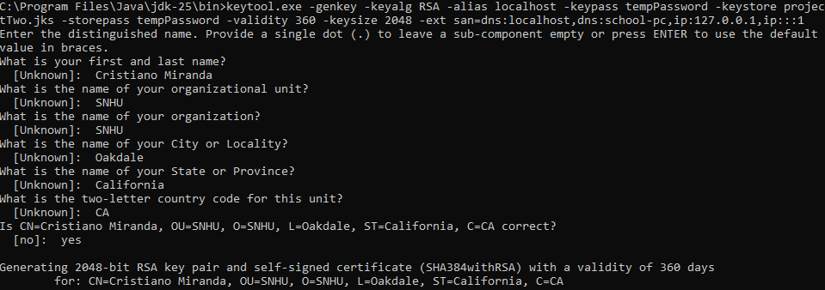

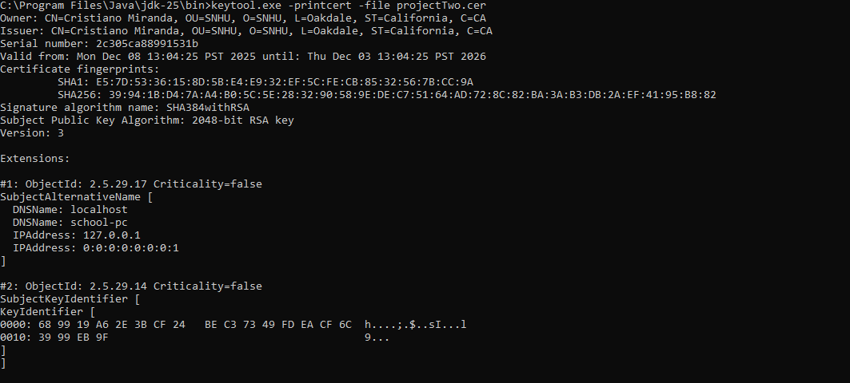



Deploy Cipher
Insert a screenshot below of the checksum verification.

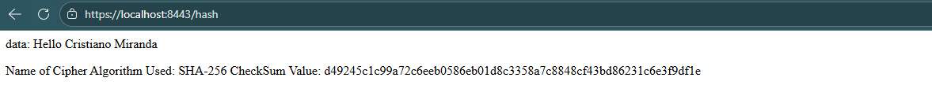

Secure Communications
Insert a screenshot below of the web browser that shows a secure webpage.

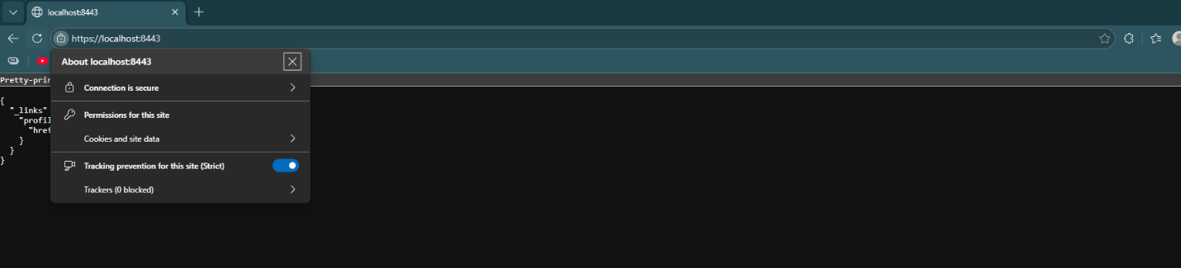

Secondary Testing
Insert screenshots below of the refactored code executed without errors and the dependency-check report.

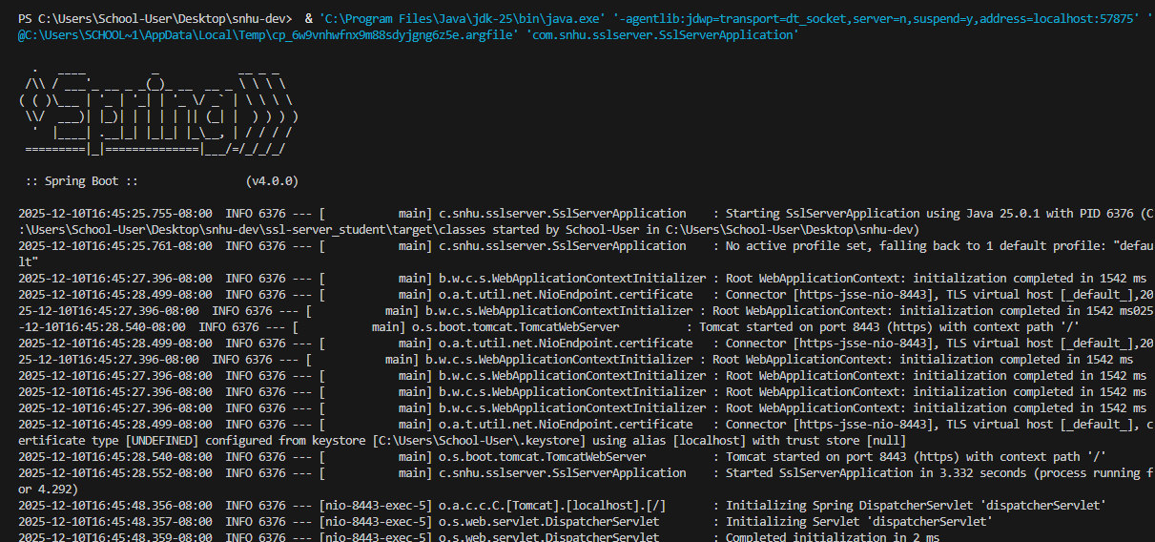

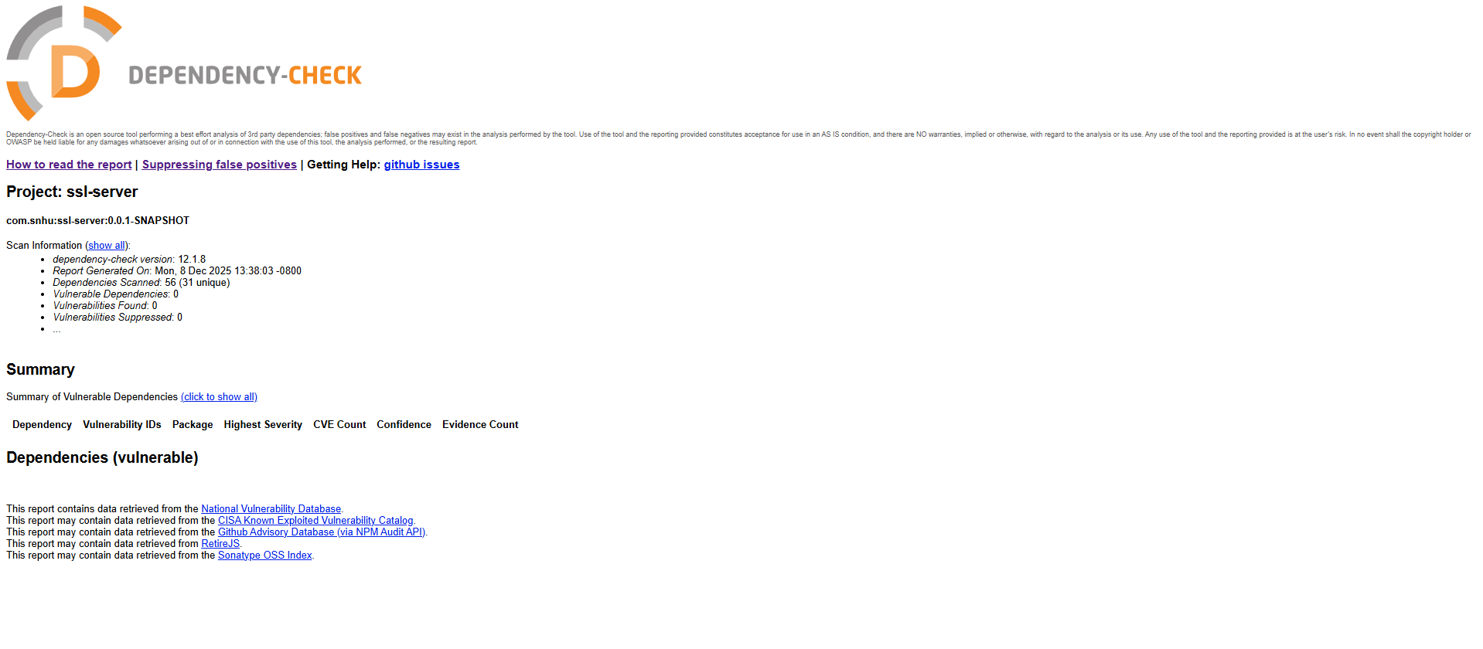

Functional Testing
Insert a screenshot below of the refactored code executed without errors.

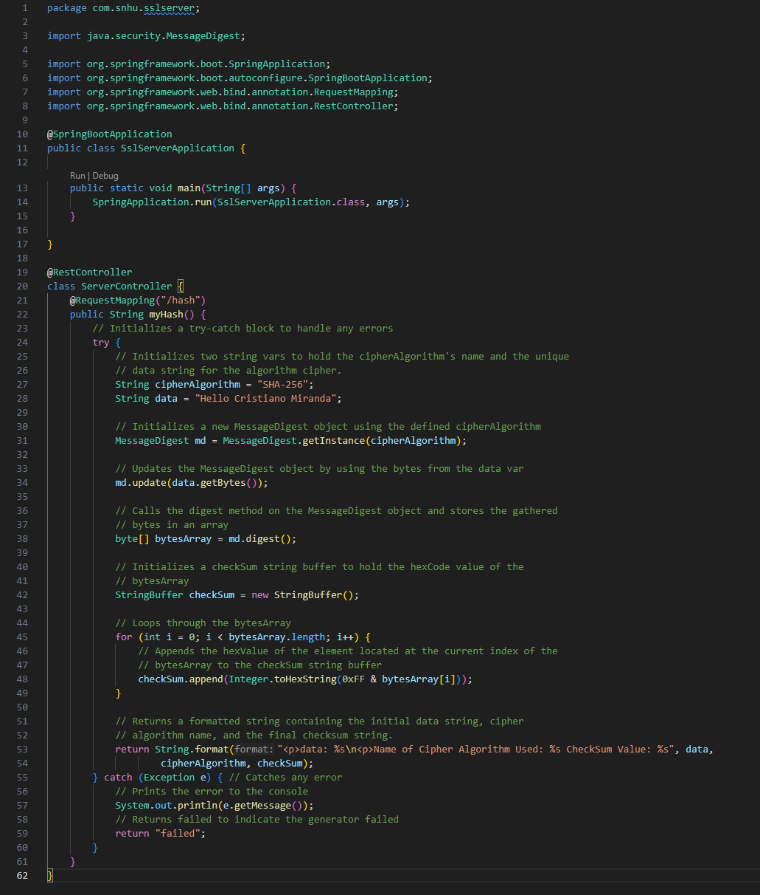

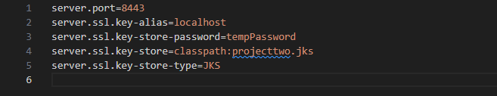

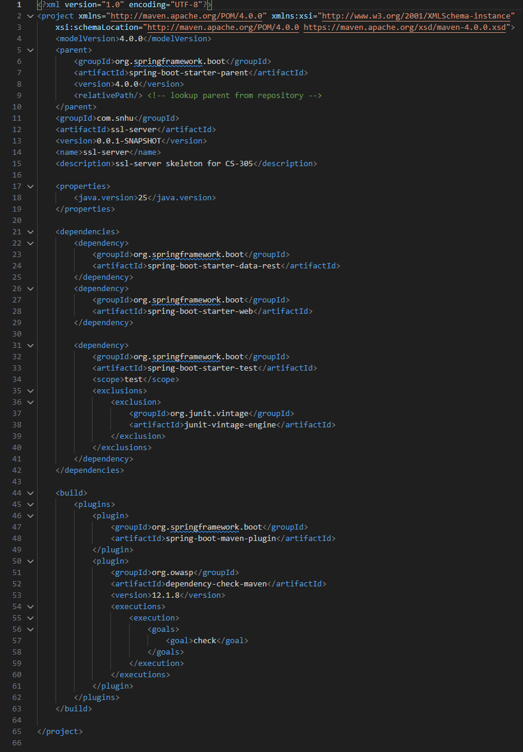

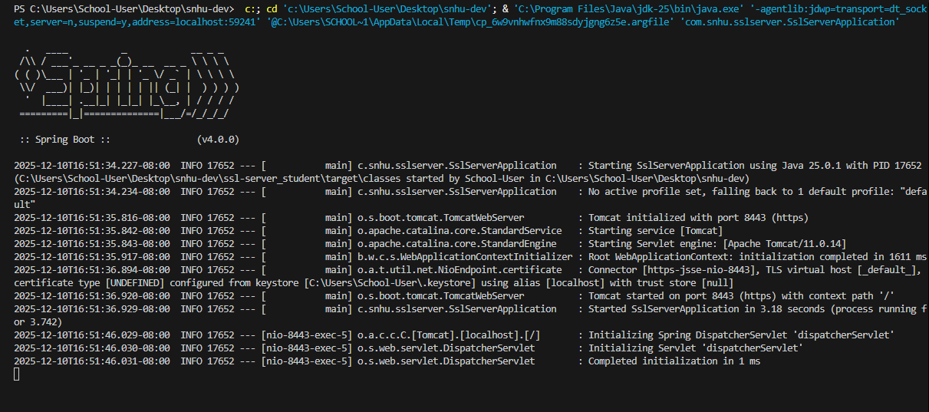

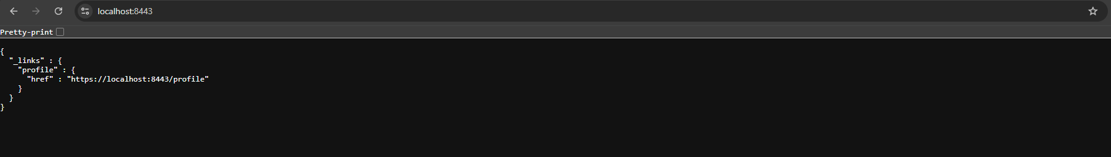

Summary

Upon refactoring this code, multiple security improvements were made to ensure the project remains secure and has no known vulnerabilities, helping to prevent user and sensitive data from being compromised. Multiple security areas were improved or newly implemented in this project during code refactoring. The most important security area improved was Client/Server, with the switch to HTTPS and the generation of a certificate and private key. The process entailed switching to HTTPS to allow users to connect to the site in a secure manner by encrypting the connection, preventing outside parties from eavesdropping or intercepting data sent between the user and the server. To enable this connection, the project was reworked to use a private key to validate its identity before any user can connect. In doing this, the user can provide a certificate to a certificate authority, which will then validate the site's identity before the user connects by comparing the certificate to the private key, ensuring that the user is directed to the client's site rather than a masquerading site.
Additionally, another important security area, Input Validation, was improved by implementing a checksum generator using the SHA-256 hashing function to validate data as it is transferred between locations. Any data that runs through this function will generate a value unique to it; thus, data can be run through it before and after transfer, and comparing the strings will provide validation that the data has remained consistent. This check ensures that the user and server can verify that the data was transmitted correctly and has not been altered by malicious users, helping prevent malicious code or data from running in the system.
In terms of implementing new security areas, a new security layer was introduced in the form of APIs. To introduce this new security layer, the project was reworked to use a new RestController to handle various HTTP requests, specifically a GET request. Using the RestController allows users to navigate to a specific endpoint to trigger or receive the data they need. For this project, a new "/hash" endpoint was introduced to allow users to generate and retrieve a checksum. Having this endpoint helps reduce the security risks associated with transferring or accessing data over the internet by allowing proper authentication and security measures to be implemented in the future to prevent unauthorized users from accessing sensitive data or injecting malicious data through these endpoints.
Finally, the arguably most important security area improved during this refactor was Code Quality, which was enhanced by updating multiple dependencies to their latest versions. Before updating, the dependency check flagged over 150 vulnerabilities in the project that could compromise users and the server itself. Following good coding practices by updating dependencies now and in the future will help ensure that known vulnerabilities in the code are addressed and that the project remains free of them.

Industry Standard Best Practices

The refactoring of this code helped improve project security by patching known vulnerabilities and adding additional security layers in line with industry standards and practices. To accomplish this, specific methods and practices were reinforced or introduced into the project. Changes such as switching to HTTPS and using a certificate authority to validate the site's identity are recommended industry practices that help ensure users connecting to the site are secure. Additionally, implementing a checksum value generator is another practice recommended by the industry, as it helps verify that data has not been tampered with after transfer. One of the most significant new features added to the project is based on an industry recommendation to use a RestController to handle HTTP requests, as it simplifies implementing authorization and additional security when adding specific RESTful features to a project. Finally, the most important improvement to the project's security came from the industry's most important practice: maintaining a project's dependencies and keeping them up to date.
Applying these recommendations and practices will help ensure that future changes to the project are made securely. Utilizing the knowledge and recommendations of others in the industry can help a company maintain an appropriate level of security even as new threats emerge. Protecting users and their sensitive information is one of the most important goals of any company, as failing to do so can result in a loss of trust between the users and the company. Maintaining a secure project is of the utmost importance, and by following industry standards and practices that nearly every company follows, a company can be assured that its users and their sensitive information are adequately protected.
References
Jena, B. K. (2023, August 29). What Is SHA-256 Algorithm: How it Works & Applications | Simplilearn.
Simplilearn.com. https://www.simplilearn.com/tutorials/cyber-security-tutorial/sha-256-algorithm
SHA1 vs SHA2 vs SHA256 – What’s the difference? (2018, October 30). RapidSSLOnline Blog.
https://www.rapidsslonline.com/blog/sha1-vs-sha2-vs-sha256-whats-the-difference/

